Anglo-Chinese Junior College
H2 Mathematics 9740
Qn | Paper 1 Solution
1(a) | 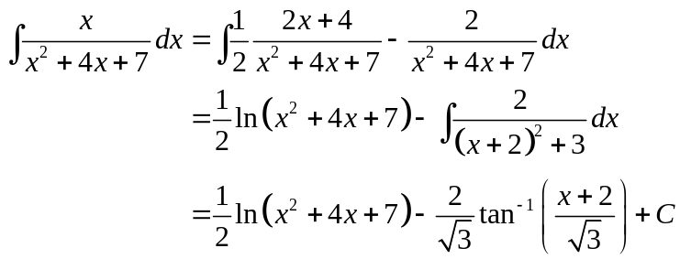
(b) | 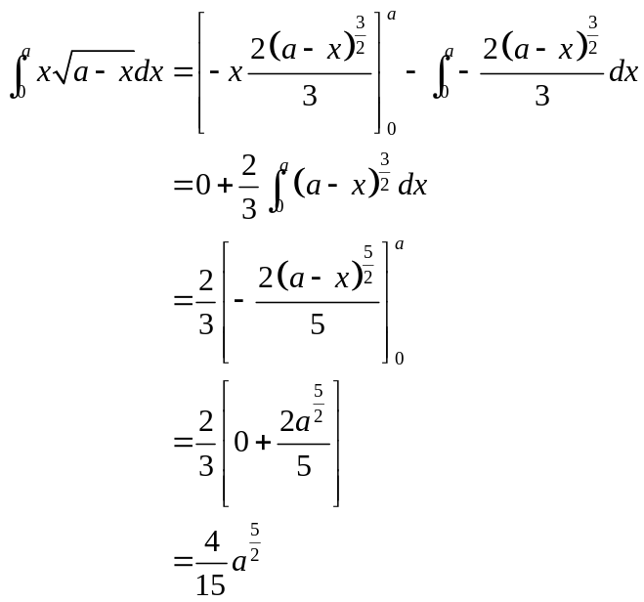
2 | 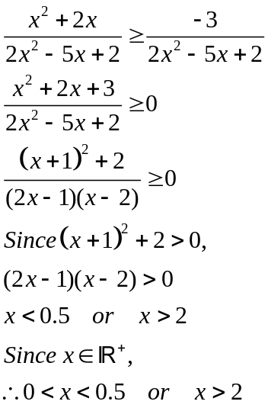
3 | When , 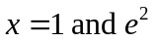  (1,0)  (e²,0)  0  y  x  y=f(x)  When , it cuts at 2 points on the curve. Therefore it is not a one to one function. Thus, 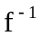does not exist.  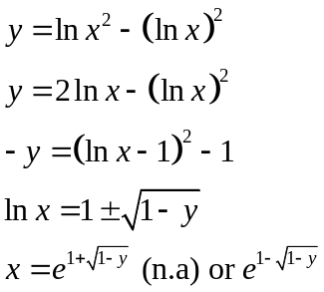  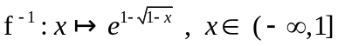  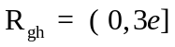
4 (i) | Let n be the number of years after 2013.  Tom’s pay 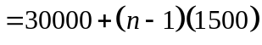  Jerry’s pay 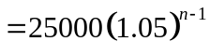  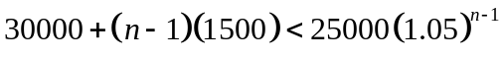  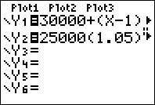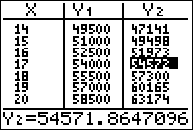  From the table, 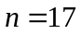.  Hence the first year in which Jerry’s pay is higher than Tom’s is 2029.
(ii) | Tom’s total income 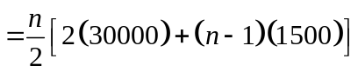  Jerry’s pay 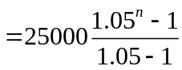  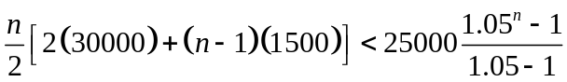  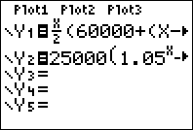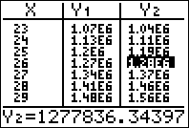  From the table, 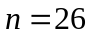.  Hence the first year in which Jerry’s pay is higher than Tom’s is 2038.
5 | 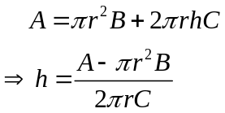  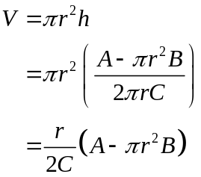  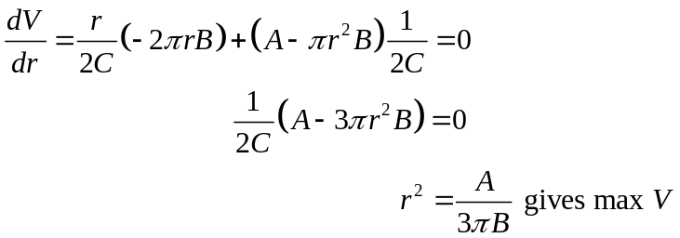  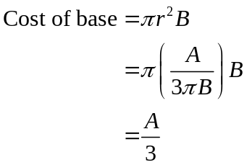
6 | 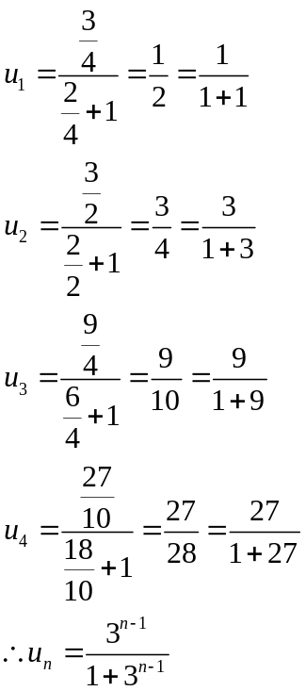  Let P(n) be the statement 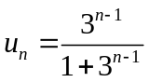 for all 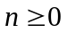.  When 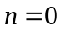, LHS = 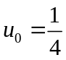  RHS = 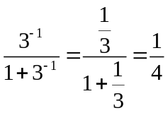  LHS = RHS P(0) is true.  Assume that P(k) is true for some 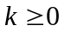, i.e., 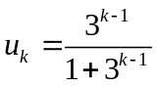.  To prove P(k + 1) is true, i.e., 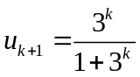,  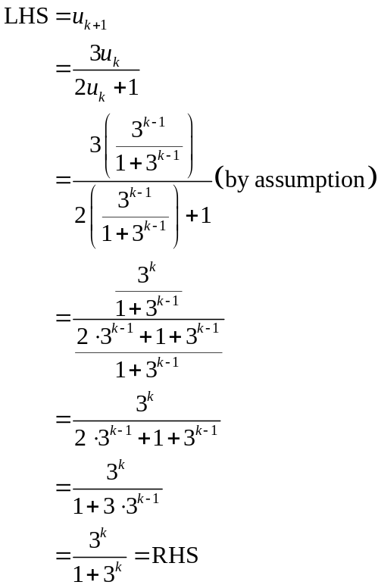  Since P(0) is true and P(k) is true ⇒ P(k+1) is true, by the Principle of Mathematical Induction, we conclude that P(0), P(1), P(2), P(3), … are all true. Hence P(n) is true for all integers.
7 | 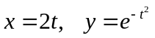  0  x  y  (0, 1)    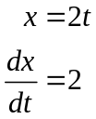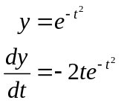  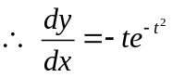  Equation of normal at 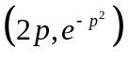 is 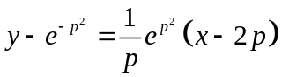  Equation of normal at 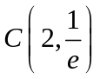 is 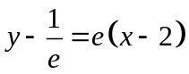  At 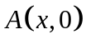: 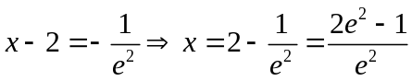  At 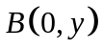: 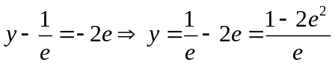  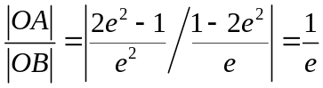  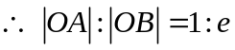
8 | 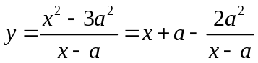  Asymptotes: 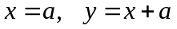  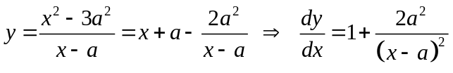  Since 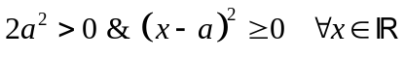, 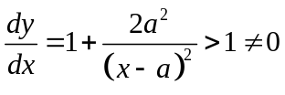  has no stationary points. (shown)  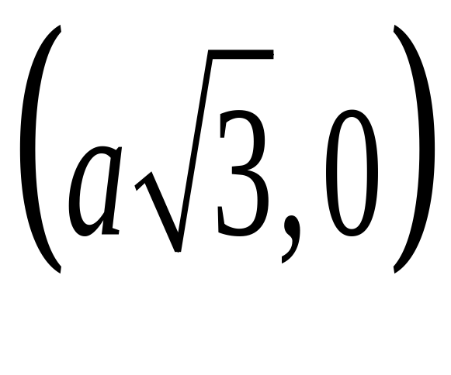  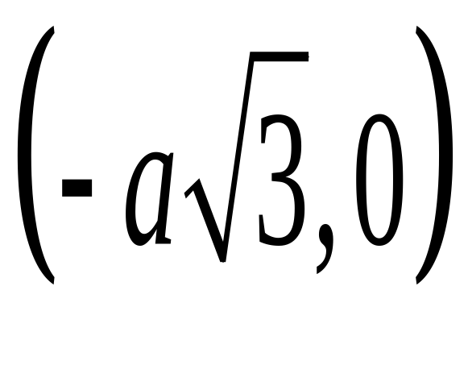  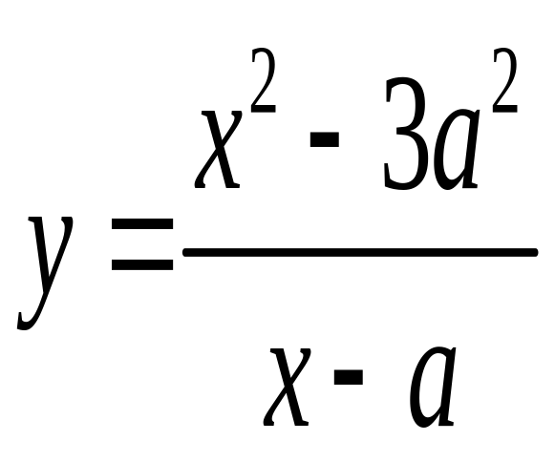  x  y  x=a  y=x+a  0  (0,3a)  Axes intercepts: , , 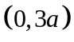  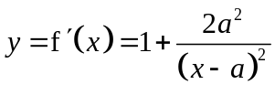  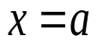  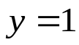  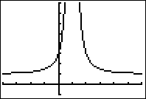  From the graph of 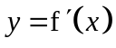, 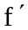 is increasing for  OR  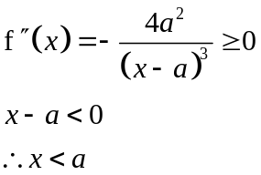
9 | 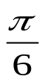    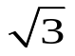  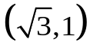  2  1  −2  2  O  −2  R  Re(z)  Im(z)  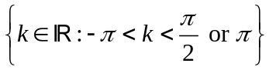 or 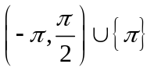
10  (i) | 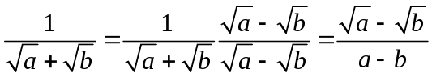
(ii) | 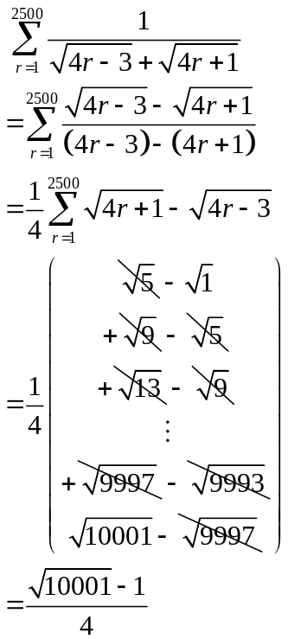
(iii) | 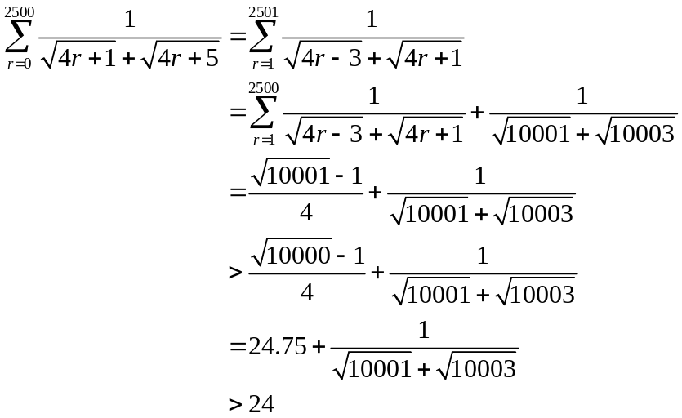
11  (i) | 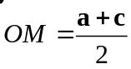  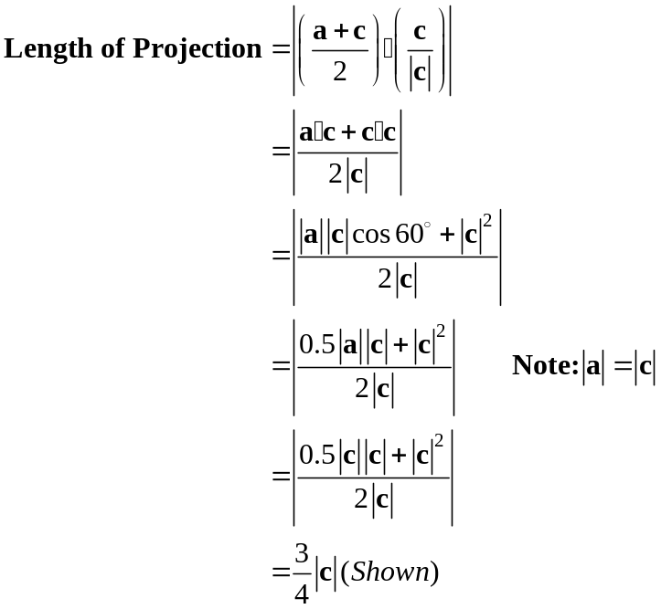
11  (ii) | 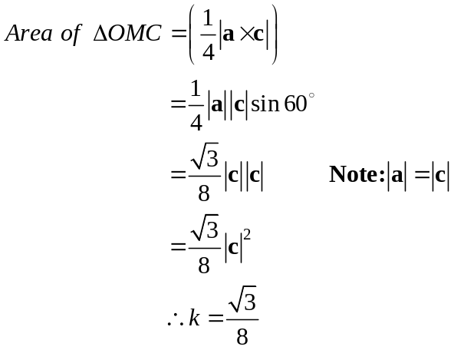
11  (iii) | 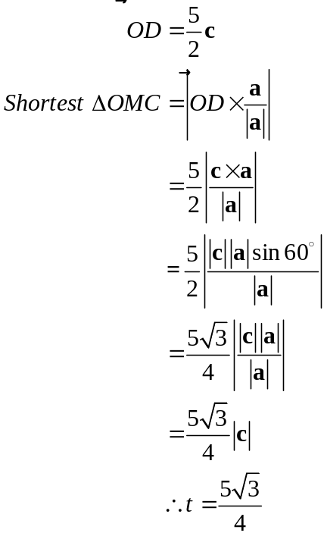
12 | 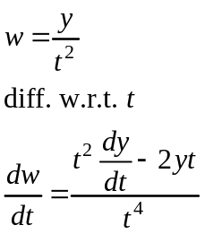  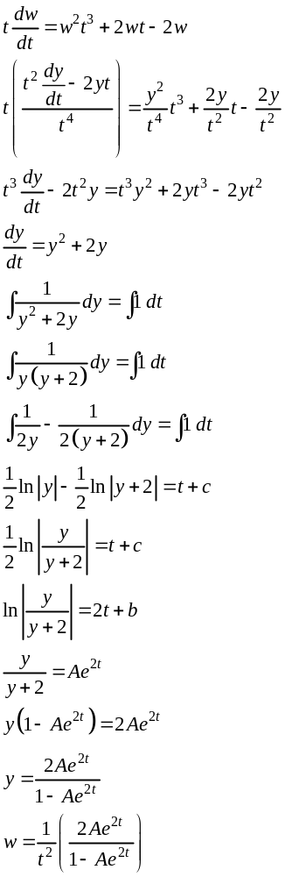  x  y  A>0  For A=0 is the x-axis.
13 | Common ratio r = 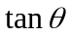. For 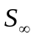to exist, 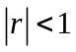, i.e.  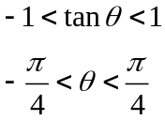  For in this range,  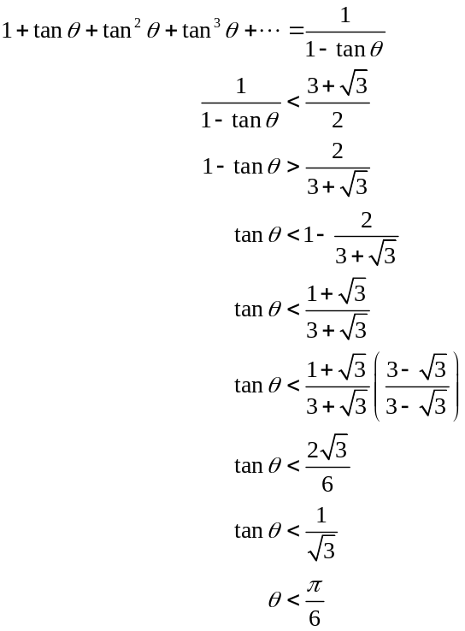  Hence 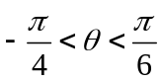.
14(a) | 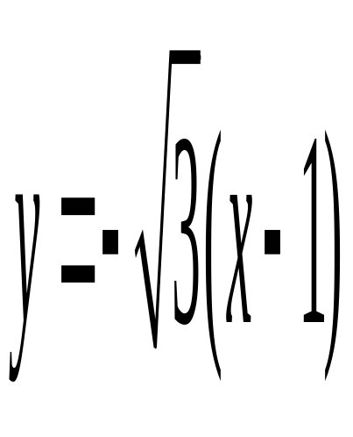  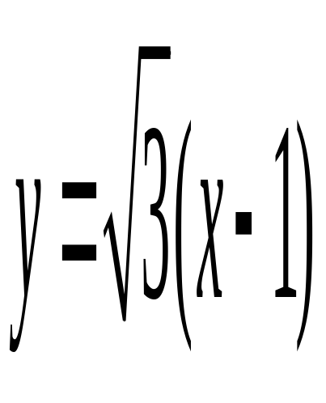  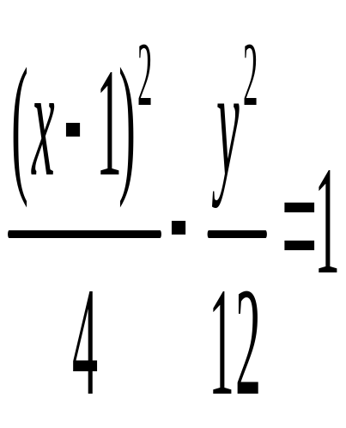  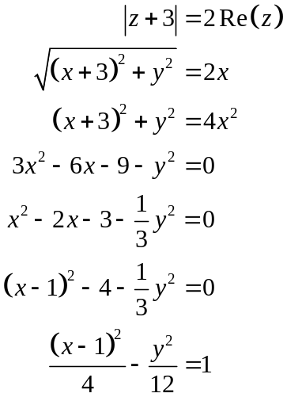  (-1, 0)  (3, 0)  x  y  Axes intercepts: 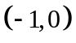, 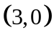  Asymptotes: 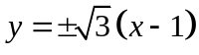
14(b) | 